**LARAVEL**

Laravel is a free , Open source and one of the most popular PHP Web Framework based on MVC architectural pattern.

Developed by Taylor Otwell in June 2011.

View

MVC

USES

Create APIs

Create Web App

**MVC Pattern ?**

Controller

Model

User Interface - HTML

Business Logics

Mediater between Model and View

Database SQL Queries

**How Mediator work?**

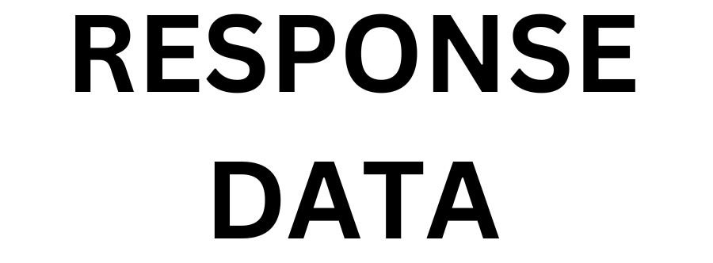

CONTROLLER

VIEW

MODEL

USER

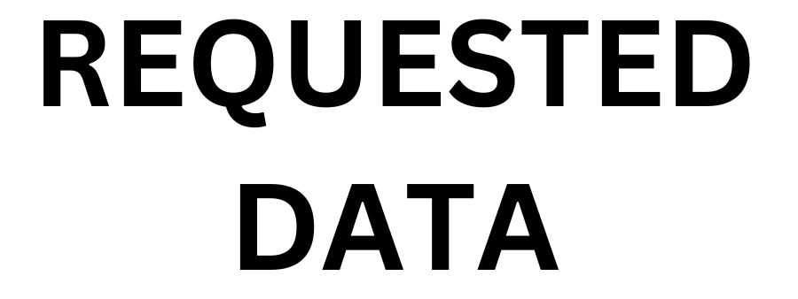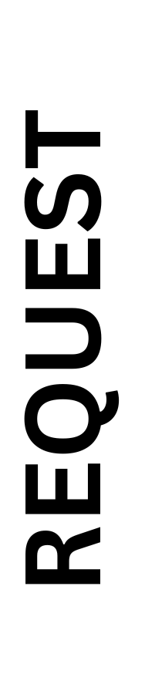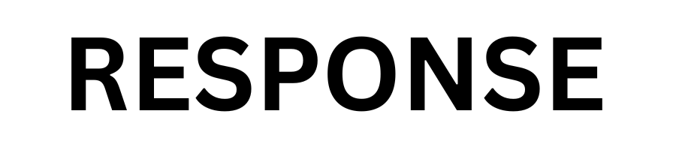

**Benefits of MVC Framework !**

* Organized Code.
* Reduces the complexity of Web Application.
* Easy to maintain.
* Easy to Modify.
* Code reusability.
* Improve collaboration.
* Independent block.

**What is Framework ?**

Programming Framework are sets of pre-written code and libraries that provide a foundation for developing software applications.

|  |  |  |
| --- | --- | --- |
| **Pre-written code & libraries** | **Benefits** | **Example** |
| * Tools * Components * Models | * Code organization * Reusability * Standardization * Testing & Debugging support * Community & Support | * Database component * Pagination * Session Management * Form handling * Security Authentication * APIs * Payments gateway * Caching |

**Benefits of Laravel Framework !**

* Open source
* Elegant syntax.
* MVC architecture
* Database migration & ORM – ( Object Relation Management )
* Robust routing system
* Command line interface – ( Composer )
* Powerful template engine – ( Blade template )
* Authentication & Authorization
* Testing & Debugging
* Security – ( XSS, CSRF, SQL Injection )
* Scalability and Performance
* Robust ecosystem and Community